Date:

TASK 3: Bell States and Entanglement Entropy

Aim: To construct Bell States via Tensor Products and Measuring Entanglement Entropy in Bipartite.

- Construct all four Bell states (|Φ⁺ , |Φ⁻ , |Ψ⁺ , |Ψ⁻ ) using quantum gates (Hadamard and CNOT).

- Measure their entanglement entropy to verify that they are maximally entangled (entropy = 1).

- Compare with a product state (|00 ) to confirm it has zero entanglement (entropy = 0).

1. Mathematical Model

1.1 Quantum Gates Representation

a. Hadamard Gate (H)
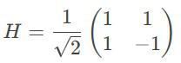

Transforms basis states:
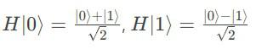

b. Identity Gate (I)
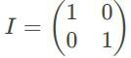

Leaves qubit states unchanged.

c. CNOT Gate
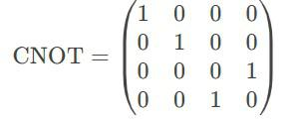

Flips the target qubit if the control qubit is ∣1 .

1.2 Bell States Construction
Bell states are constructed by applying H to the first qubit followed by CNOT:

a. |Φ
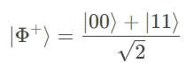

Constructed from ∣00 .

- |Φ
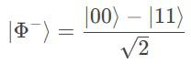

Constructed from ∣10 .

- |Ψ
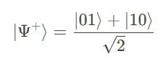

Constructed from ∣01 .

- |Ψ
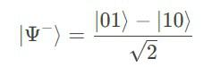

Constructed from ∣11 .

1.3 Partial Trace Operation

Given a density matrix ρ for a bipartite system A⊗B, the partial trace over subsystem B is
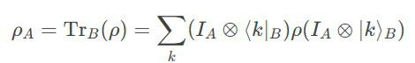

where {∣k B} is a basis for B.

1.4 Entanglement Entropy (Von Neumann Entropy)

For a pure bipartite state ∣ψ AB, the entanglement entropy is the von Neumann entropy of the reduced density matrix ρ_{A}=Tr_{B}(∣ψ ψ∣).
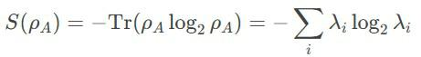

where λi are the eigenvalues of ρA.

- Algorithm

Define quantum gates

Create entangled Bell states using tensor products. Reshape the states for partial trace computation. Calculate entanglement entropy of bipartite state
Compute eigenvalues (using eigh for Hermitian matrices) Compute von Neumann entropy.

- Program

import numpy as np

from math import log2, sqrt

print("\n" + "="*50)

print("TASK 3: BELL STATES AND ENTANGLEMENT ENTROPY")

print("="*50)

# Define quantum gates

H = 1/sqrt(2) * np.array([[1, 1], [1, -1]]) # Hadamard gate

I = np.eye(2) # Identity gate

CNOT = np.array([[1,0,0,0], [0,1,0,0], [0,0,0,1], [0,0,1,0]]) # CNOT gate

class BellStates:

@staticmethod

def phi_plus():

"""Construct |Φ⁺ = (|00 + |11 )/√2"""

state = np.kron([1, 0], [1, 0]) # |00

state = np.kron(H, I) @ state # Apply H to first qubit return CNOT @ state # Apply CNOT


@staticmethod

def phi_minus():

"""Construct |Φ⁻ = (|00 - |11 )/√2"""

state = np.kron([0, 1], [1, 0]) # |10

state = np.kron(H, I) @ state

return CNOT @ state

@staticmethod

def psi_plus():

"""Construct |Ψ⁺ = (|01 + |10 )/√2"""
state = np.kron([1, 0], [0, 1]) # |01

state = np.kron(H, I) @ state

return CNOT @ state

@staticmethod

def psi_minus():

"""Construct |Ψ⁻ = (|01 - |10 )/√2"""

state = np.kron([0, 1], [0, 1]) # |11

state = np.kron(H, I) @ state

return CNOT @ state

def partial_trace(rho, dims, axis=0):

"""

Compute partial trace of density matrix rho

dims: list of dimensions of each subsystem [dA, dB]

axis: 0 for tracing out B, 1 for tracing out A

"""

dA, dB = dims

if axis == 0: # Trace out B

rho_reduced = np.zeros((dA, dA), dtype=complex)

for i in range(dA):

for j in range(dA):

for k in range(dB):

rho_reduced[i,j] += rho[i*dB + k, j*dB + k]

else: # Trace out A

rho_reduced = np.zeros((dB, dB), dtype=complex)

for i in range(dB):

for j in range(dB):

for k in range(dA):

rho_reduced[i,j] += rho[k*dB + i, k*dB + j] return rho_reduced


def entanglement_entropy(state):

"""

Calculate entanglement entropy of bipartite state

Input: state vector or density matrix

Output: entanglement entropy

"""

- Convert state to density matrix if it's a state vector if state.ndim == 1:

rho = np.outer(state, state.conj()) else:
rho = state

- Partial trace over subsystem B (assuming 2-qubit system) rho_A = partial_trace(rho, [2, 2], axis=1)

- Compute eigenvalues (using eigh for Hermitian matrices) eigvals = np.linalg.eigvalsh(rho_A)

- Calculate von Neumann entropy


entropy = 0.0

for lamda in eigvals:

if lamda > 1e-10: # avoid log(0)

entropy -= lamda * log2(lamda)

return entropy

# Example usage

if __name__ == "__main__":

# Construct Bell states

phi_p = BellStates.phi_plus()

phi_m = BellStates.phi_minus()

psi_p = BellStates.psi_plus()

psi_m = BellStates.psi_minus()

print(f"Bell state |Φ⁺ =", phi_p)

print(f"Bell state |Φ⁻ =", phi_m)

print(f"Bell state |Ψ⁺ =", psi_p)

print(f"Bell state |Ψ⁻ =", psi_m)

# Verify entanglement entropy (should be 1 for maximally entangled states)

print(f"Entanglement entropy of |Φ⁺ : {entanglement_entropy(phi_p):.4f}")

print(f"Entanglement entropy of |Φ⁻ : {entanglement_entropy(phi_m):.4f}")

print(f"Entanglement entropy of |Ψ⁺ : {entanglement_entropy(psi_p):.4f}")

print(f"Entanglement entropy of |Ψ⁻ : {entanglement_entropy(psi_m):.4f}")

  - Verify product state has zero entanglement entropy product_state = np.kron([1, 0], [1, 0]) # |00
print(f"Entanglement entropy of |00 : {entanglement_entropy(product_state):.4f}")

output:
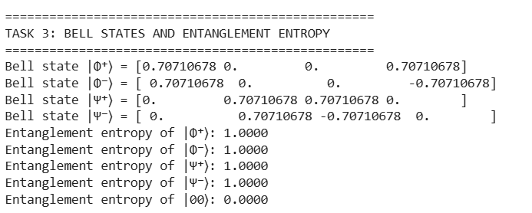

- Result

Bell states were constructed and their entanglement entropy was accurately calculated.

